2026 PW Summer Gathering/Retreat
July 16 – 18, 2026
Antiochian Village Retreat & Conference Center, Ligonier, PA
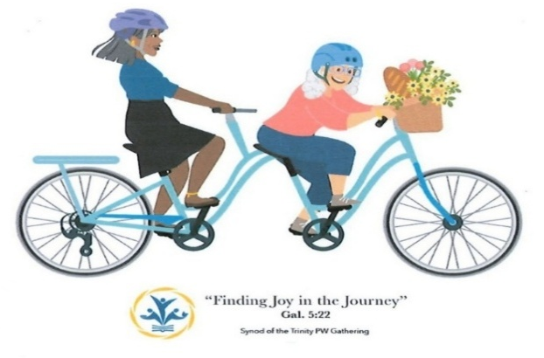
“Finding Joy in the Journey” (Gal. 5:22)

Thursday Afternoon: Check In beginning 3:00 pm – Dinner at 5:00 pm – Opening Plenary & Keynote 6:30 pm
Friday: Morning Plenary & Workshops; Afternoon Free time (2:30- 4:30) – Evening Worship – Movie night
Saturday Morning: Final Plenary, Business meeting & Closing Worship – Check out & Lunch

Guest speaker—CeCe Armstrong, Co-Moderator 2024-2026
PC(USA) General Assembly

Join us for Lively Worship, Special Workshops, Great Food, Inspirational Small-Group Time, Spirituality Walk, Toe-tapping music, Silent Auction, Games, Crafts, Mission Opportunities and More!!

Registration:
Triple Occupancy Room - $225 per person Double Occupancy Room - $275 per person
Single Occupancy Room - $350 per person


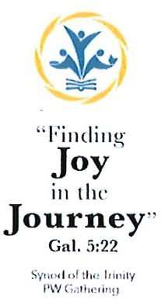
Registration Includes: 2 Nights hotel style lodging, 6 meals (2 breakfasts, 2 lunches, 2 dinners), plus snacks & beverages, conference folder, materials, Joy Room activities, PW resources; Choice of 2 workshop sessions on Friday; Worship service w/ Communion on Friday evening with Rev. CeCe Armstrong (PCUSA Co-Moderator 2024-2026); Optional Early morning Yoga or Prayer Circle activities (before breakfast); Evening relaxation and community activities, including Friday Movie night (“Up!”) w/popcorn.

Hosted by The Presbyterian Women in the Synod of the Trinity

