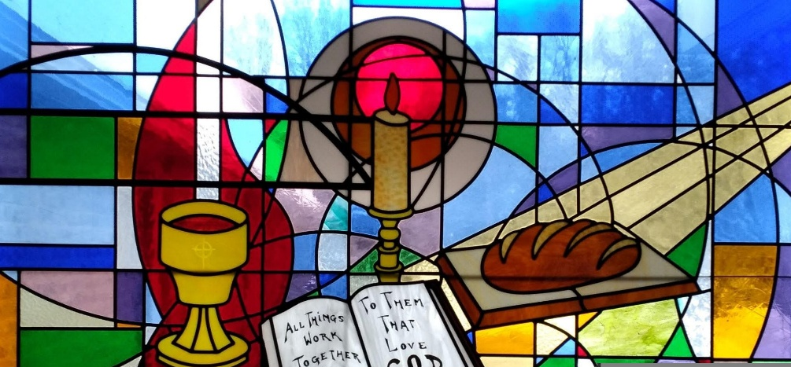
1 Corinthians 12.12. "The body is a unit, though it is made up of many parts; and though all its parts are many, they form one body. So it is with Christ."
Presbyterian Women of Lake Erie Presbytery - Spring Gathering - Saturday April 25Th 10:00 am - 1:30 pm
Eastminster Presbyterian Church
Registration from 9 -10 with a continental breakfast provided by Harborcreek and Emmanuel Church Women.
“The Fabric of the Church”
Chaplain (Major) Mel Baars O'Malley, currently stationed at Walter Reed Medical Center in Bethesda, MD will be the keynote speaker. She will present: Compassion and Connection: Illuminating God’s Presence through Spiritual Care.
In addition, women from Eastminster will highlight six biblical women who have a connection to fabric or craftsmanship. We will explore how we can each relate to these biblical characters. Each participant will receive a quilt block to sign and place it in a receptacle associated with the character they most identify with. It will be a faith filled opportunity to connect with women and learn about the “Fabric of our Church.”
To support mission work – Eastminster is asking us to bring canned or nonperishable food to support the Wesleyville Interfaith Food Pantry. This pantry serves needy people in Eastminster’s area.
To register please send an email to: office@eastminstererie.com or call the church office at 814-455-7819.
Registration deadline is April 13th

If you have any questions, please contact PWLEP Moderator Karen Haas karenhaas79@gmail.com or call/text 814-397-1619

