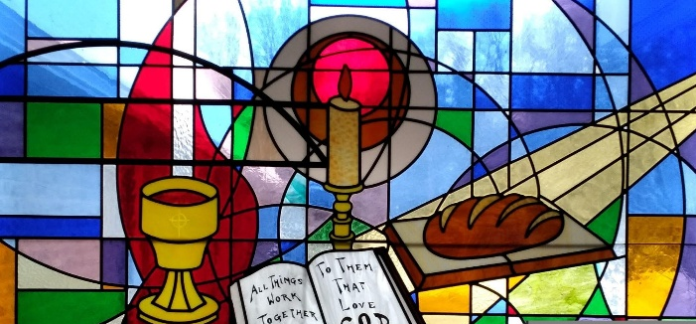
Presbyterian Women of Lake Erie Presbytery
Spring Gathering
“The Fabric of the Church”
Saturday April 25th, 2026 – 10:00 am - 1:30 pm
Eastminster Presbyterian Church 2320 East Lake Rd. Erie, Pa. 16511
The program starts at 10:00 – registration/continental breakfast 9:00-9:45.
Church ________________________________ Contact person ____________________
Phone__________________________________ Email _____________________________
Women attending:
1)_______________________________________________ 5) _____________________________________
2)_______________________________________________ 6) _____________________________________
3)_______________________________________________ 7) _____________________________________
4)_______________________________________________ 8) _____________________________________
The mission project we are supporting at the Spring Gathering is the Wesleyville Interfaith Food Pantry. Please bring canned goods or nonperishable food to donate to this mission project.
The fee for lunch is $10. You can mail a check or pay at registration. Please make checks payable to Eastminster Presbyterian Church. To register - email the church at office@eastminstererie.com or call the church office at 814-455-7819. Please let them know if anyone has special dietary requirements.
If you would like childcare - please contact Karen Haas (814-397-1619) by April 8th so arrangements can be made.
Registration sheets can also be mailed to Eastminster Presbyterian Church but please leave extra time for them to arrive as the mail can be slow. If you have any questions, please contact Moderator, Karen Haas 814-397-1619 or email her at karenhaas79@gmail.com
Registrations are due by Monday ------April 13th.

